**Tribhuvan University**

**Institute of Engineering**

**Himalaya College of Engineering**



**PROGRESS REPORT OF MINOR PROJECT TITLED**

**“HOME DECOR MARKETPLACE WITH RECOMMENDATION SYSTEM”**

**[CT 654]**

**SUBMITTED TO:**

**DEPARTMENT OF ELECTRONICS AND COMPUTER**

**SUBMITTED BY:**

**AJAY MAHARJAN (HCE075BCT006)**

**ASHISH RAI (HCE075BCT042)**

**NIBENDRA BAJRACHARYA (HCE075BCT015)**

**SUJAN MAHARJAN (HCE075BCT037)**

**FEBRUARY, 2022**

# ACKNOWLEDGEMENT

We take this occasion to thank our parents for their consistent support and encouragement. We are immensely thankful to our college, **Himalaya College of Engineering**, for including the project in the syllabus. We are also very grateful for the college for providing us with this opportunity. Furthermore, we extend our sincere and heartfelt thanks to our **Head of Department, Er. Ashok GM,** for providing us with the right guidance and advice at the crucial junctures, and for showing us the right way. We would like to express our deep gratitude towards **Er. Ramesh Tamang** as well as other faculty membersfor their proper guidance and inspiration.Finally, we would like to give special thanks to acknowledge all the people who have helped us towards the development of this proposal.

# ABSTRACT

One of the most important applications of the Internet is that of E-commerce, which is expanding and developing very quickly due to its many advantages. Electronic Commerce or E-commerce is business transactions that take place by communication networks. E-commerce is a set of dynamic technologies, applications and business process that link organizations, customers, suppliers, and communities through electronic transactions and the electronic exchange of information products and services. It provides customers with the convenience to buy the products they need instantly from the convenience of their offices, homes and anywhere provided they can access the internet. This proposal report presents a brief description of the goals we aim to achieve with this project and the methodology we plan on using.

**Keywords:** E-commerce, Electronic Data Interchange, Electronic transactions.

# TABLE OF CONTENTS

**Contents**

ACKNOWLEDGEMENT 2

ABSTRACT 2

LIST OF FIGURES 2

LIST OF ABBREVIATIONS 2

INTRODUCTION 2

OBJECTIVES 2

LITERATURE REVIEW 2

REQUIREMENT ANALYSIS 2

1. FUNCTIONAL REQUIREMENTS 2

2. NON-FUNTIONAL REQUIREMENTS 2

FEASIBILITY ANALYSIS 2

SYSTEM DESIGN 2

METHODOLOGY 13

SOFTWARE DEVELOPMENT APPROACH 13

PROJECT TOOLS 15

ALGORITHM 16

PROJECT REQUIREMENTS 17

HARDWARE SPECIFICATIONS 17

SOFTWARE SPECIFICATIONS 17

TASKS ACCOMPLISHED 18

TASKS REMAINING 19

REFERENCES/BIBLIOGRAPHY 20

# LIST OF FIGURES

Fig (1) : Use case diagram

Fig (2) : DFD level 0

Fig (3) : DFD level 1

Fig (4) : ER diagram

Fig (5) : Class diagram

Fig (6) : Sequence diagram

Fig (7) : Activity diagram

Fig (8) : Representation of incremental model

# LIST OF ABBREVIATIONS

* CSS : Cascading Style Sheet
* COD : Cash On Delivery
* DFD : Data Flow Diagram
* E-Commerce : Electronic Commerce
* EDI : Electronic Data Interchange
* EFT : Electronic Fund Transfer
* HTML : Hyper Text Markup Language
* HTTP : Hyper Text Transfer Protocol
* ICT : Information and Communication Technology
* IDE : Integrated Development Environment
* JS : JavaScript
* SQL : Structured Query Language

# INTRODUCTION

Online marketing is a good opportunity for business promotion. E-commerce (electronic commerce) is the buying and selling of goods and services, or the transmitting of funds or data, over an electronic network, primarily the internet. These business transactions occur either as business-to-business, business-to-consumer, consumer-to-consumer or consumer-to-business. E-commerce shops have become part of our daily lives. Technological advancement has made it possible for people to sit in the convenience of their homes and still shop online without going to a physical shop.

E-Commerce entails a company accessing the internet as well as IT, such as the electronic data interchange (EDI). It concerns an internet vendor's website, trading goods or services to the user directly from the platform. The gateway uses a wireless purchase cart to pay by credit card, debit card or Electronic fund transfer (EFT). Electronic communications and digital information processes in business transactions are used to create, modify and redefine value generation relations between organizations and individuals. With the increasing spread of ICTs, specifically the Internet, the global corporate world pushes rapidly into e-commerce (Business-to-Business). As the internet enables consumers to enter the global economy, they can compare prices across areas, find out how they vary by request, and become aware of substitution. The buyers obtain a distinct advantage. Thanks to market openness, consumers can conveniently compare e-commerce offerings from different websites. The rivals would immediately be one click away from the customer if the company is electronic. If consumers aren't comfortable with certain e-goods, content's pricing or services, they can adjust even more quickly than in traditional terms. They don't need a physical store from the point of view of the vendors.

The biggest advantage from the consumer viewpoint is that it improves the shopping experience dramatically. It saves a lot of time and provides convenient access from anywhere in the world. At any time, the customer is free to place the order. Increased sales and decreased running and sustaining costs through the internet are the key advantage of e-commerce from the point of view of sellers.

For e-commerce web sites, cyber security is the most common problem. Usually, financial institutions and banks are reluctant to play an active role in supporting the e-commerce market. Retailers need the participation of banks in expanding e-scope commerce and popularity and in mitigating theft and possible losses related to credit card fraud.

Home decor is the art of making your home look nice. It refers to the aesthetic components used to make a home more attractive and visually appealing. It is inclusive of physical items and objects (furniture, art, and accessories), placement of physical items and objects, and room colors and materials (flooring, wall coverings, window coverings, and ceilings). Home décor is important because it can affect everything from our self-perception to our confidence and productivity. It reflects your personality and lifestyle.

# OBJECTIVES

* To show the amount of progress in the development of project so far as well as the work remaining for completion.
* To update project tasks based on the progress made, and implement them in order to meet all the project goals.

# LITERATURE REVIEW

Electronic commerce, or eCommerce, is a business model that lets businesses and consumers make purchases or sell things online. There are six major eCommerce business models:

1. Business to Consumer (B2C)

Business to consumer (B2C) is when a company markets its products or services directly to end users. It is the most widely known form of commerce. In eCommerce, there are five different B2C business models: direct sellers, online intermediaries, advertising-based, community-based, and fee-based.

2. Business to Business (B2B)

Business to business (B2B) is when a company markets its products or services directly to other businesses. B2B ecommerce can be broken down into two methodologies, vertical and horizontal. Vertically oriented businesses sell to customers within a specific industry. With a horizontal approach, you are selling to customers across a myriad of industries. Each approach has their own pros and cons, such as industry expertise and market depth (vertical) versus wide-spread market coverage and diversification (horizontal).

3. Business to Government (B2G)

Business to government (B2G) is when a company markets its products and services directly to a government agency. This agency could be a local, county, state, or federal agency.

4. Business to Business to Consumer (B2B2C)

In B2B2C ecommerce, a company sells products to another company which are then sold to consumers. The B2B2C model is comprised of three parts: the first business (the business of product origin), an intermediary, and the end user.

5. Consumer to Consumer (C2C)

In the C2B ecommerce business model, individuals sell goods and services directly to companies. One of the key benefits of this business model is that it allows consumers to set their own price and can also often help expand their individual reach by giving the more visibility.

6. Consumer to Business (C2B)

In C2C ecommerce, consumers sell goods or services directly to other consumers. This is most often made possible by third-party websites (such as the examples we previously mentioned) or marketplaces, that facilitate transactions on behalf of the buyers and sellers. These ecommerce marketplaces allow smaller businesses, or even hobbyists, to sell their products at their own pricing without having to maintain their own online storefront.

According to the U.S. Survey Department, manufacturing sector is the largest supplier to e-commerce sales which has 47.4% of their total shipments, followed by vendors which is having 28.6% of their total sales. Gupta (2014) in her paper “E-Commerce: Role of e-commerce in today’s business”, presents a comprehensive definition of e-commerce while isolating it from e-business. The paper enlists the different ecommerce models i.e. B2B, B2C, B2G and C2C.

Gunasekaran, Marri, McGaughey, & Nebhwani (2002) give a broad outlook of electronic commerce within organizational systems in “E-commerce and its impact on operations management”, defining it with reference to e-trading and elaborating- how it has permeated every field of business. The paper identifies the revolutionary role played by earlier internet applications like e-mail and electronic data interchange and details the revolutionary changes brought by the internet technologies in manufacturing, marketing, purchasing, design, production, selling and distribution, warehousing and human resource management. Internet based technologies have enabled businesses to shorten development, purchase and procurement cycles, maintain up to date product and market information, significantly increase the speed of communications and increase the quality of customer relationships by facilitating close contact and constant communication. The paper studies in depth, the significance of web-based technologies in different business operations, thus, improving their efficiency through effective B2B e-commerce.

Das & Ara(2015) observe in “Growth of E-Commerce in India” that though online travel and hotel bookings still control the lion’s share of e-commerce market, their share has comparatively fallen over the years due to the recent augmentation and consequent rise of e-tailing services. There has been a tremendous surge in the volume of investment in this sector. With the e-commerce markets in the west reaching their saturation, investors see tremendous potential in the Indian market, in the light of which, many startups have received funding from venture capitalists and private equity firms.

China's Alibaba Group and affiliate Ant Financial became the largest shareholders of One97 Communications, the parent of Indian e-tailer Paytm, by investing $680 million, in 2015 (Aulakh, 2015). To tap the potential of what it regards as “underdeveloped internet economy” of India, Japanese investment company and technology powerhouse Softbank invested $627 million into online retailing marketplace Snapdeal and $210 million in Ola cabs. (Mac, 2014).

Similarly, New York firm Tiger Global Management has funded companies such MakeMyTrip, Flipkart, Myntra and Quickr. The availability of funds has presented a favorable ecosystem and growth opportunities for big as well as small companies. It has enabled local startups to survive in cut throat competition against foreign giants and has facilitated the penetration of e-commerce to every facet of human life; such that the differentiation between e-commerce and traditional business is getting blurred.(Aggarwal, 2014).

Through “Probles and Prospects of E-Commerce”, Raghunath & Panga (2013) present a comprehensive analysis of various nuances of e-commerce while accentuating that, in present time every business activity, be it advertising, ordering, payment etc., can be performed in the digital ecosystem. The paper also enlists numerous points on the importance of e-commerce which are responsible for its development as the new convention. It has enabled the creation and exploitation of new business opportunities, at the same time increasing the say of customers in the development of new products and services. E-commerce has not only augmented the performance of internal business management, but, has also enabled better customer relationships by promoting a business model that is essentially based on information sharing. The accessibility of internet connectivity and other online tools herald a new revolution. SWOT analysis of e-commerce conducted by Awais & Samin (2012) highlights ubiquity, low operating cost, improved customer interaction and time saving as the unique strengths of e-commerce, but, at the same time accentuates upon the necessity for the firms to adapt themselves to the changing environment and innovate constantly to come up with better offerings for customers.

With an increase in the number of players in the B2C segment, competition for the first position is set intensify, making it imperative for the firms to enhance service quality and to invest in logistics, so as to derive benefits from increase in the disposable income of households, rise in internet subscriptions and infiltration of mobile commerce. (Das & Ara, 2015).

In the face of rising competition, the survival of the firms will depend upon how efficiently they are able to bridge the existing gaps in e-commerce transactions. The ubiquitous nature of internet has enabled e-commerce to defy geographical boundaries and permeate different markets, so as to elicit demand from sub-urban and rural areas, after having successfully tapped its potential in metropolitan cities.

Apart from Internet Marketing, Deshmukh, Deshmukh & Thampi (2013) recognize another important development: m-commerce, which they identify as a subset of e-commerce. “Transformation from Ecommerce to M-commerce in Indian Context” reviews the current and potential status of e-commerce and m-commerce in the Indian market, while projecting the latter as the potential future. The paper discerns ubiquity, personalization, flexibility and immediacy as the singular advantages of m-commerce.

# REQUIREMENT ANALYSIS

## FUNCTIONAL REQUIREMENTS

The functionalities that the system should provide in order to satisfy the needs and requirements of the users are as listed below:

1. **Login and Register**The users must be able to register and login to access full functionality of the system.
2. **Browse products**The users can browse different products with an option to filter items based on different categories. The system should sort the list of products based on ratings, popularity.
3. **View description of products**The users should be able to view the descriptions of the products. The descriptions include specifications of the products.
4. **Add/Remove from cart**The system should provide users with an option to add products into their virtual cart which can later be checked out. The users can remove items from the cart later on.
5. **Payment options**The users must be able to choose one of the many payment options. The payment options include **Cash on Delivery, Digital Payment.**
6. **Recommend products**The system must recommend different products to the users based on their interest. The recommended products should be based on the purchase records of others users.
7. **Notification**The system should notify users about stock, discounts and offers of the products. Also, the users must be notified about the changes in the system.
8. **Chat system**The system should provide the users with the provision to communicate with the sellers and with the customer support team also.

## NON-FUNTIONAL REQUIREMENTS

1. **Reliability**The system has to be reliable by properly handling unwanted actions or exceptions.
2. **Availability** The system should have uptime to the maximum level.
3. **Performance**The User Interface should be interactive by responding to the actions fast.
4. **Scalability**The system should be capable of supporting the growth and address the concurrent actions.
5. **Maintainability**The system should be maintainable after the deployment.
6. **Security**The system should store the users’ credentials securely.
7. **Usability**The User interface should be simple and easily adaptable for the users to operate the system with ease.

# FEASIBILITY ANALYSIS

## TECHNICAL FEASIBILITY The web application uses software technologies and tools which are freely available, the technical skills required can be easily manageable. There are many commerce sites available for analysis with proper documentations. The hardware technology required for operation is easy to obtain since the application can run on any computer with a web browser and an internet connection. The system must be adequate enough to hold the marketplace database and should be manageable in future. So, the hardware and software technicalities are within accessible boundaries.

## OPERATIONAL FEASIBILITY

Since the web application is interactive and data drive, the user can easily be familiarized with the software system. This system highly focuses on design-dependent parameters like reliability, maintainability, supportability, usability, sustainability, etc. that fits into the operating functions of the project. As the system is accessible with a web browser, it can be easily operated to obtain the desired functionalities, both by the user and the administrator.

## ECONOMIC FEASIBILITY Economic feasibility attempts to weigh the costs of developing and implementing a new system, against the benefits that would increase from having the new system in place. This feasibility study gives the top management the economic justification for the new system. There could be various types of intangible benefits on account of automation. These could include increased user satisfaction, improvement in product quality, better expediting activities, improved accuracy of operations, better documentation and record keeping, faster retrieval of information, better employee morale. All these may be achieved with a little investment and some periodic maintenance of the system which will prove beneficial to the organization in the long run.

# SYSTEM DESIGN

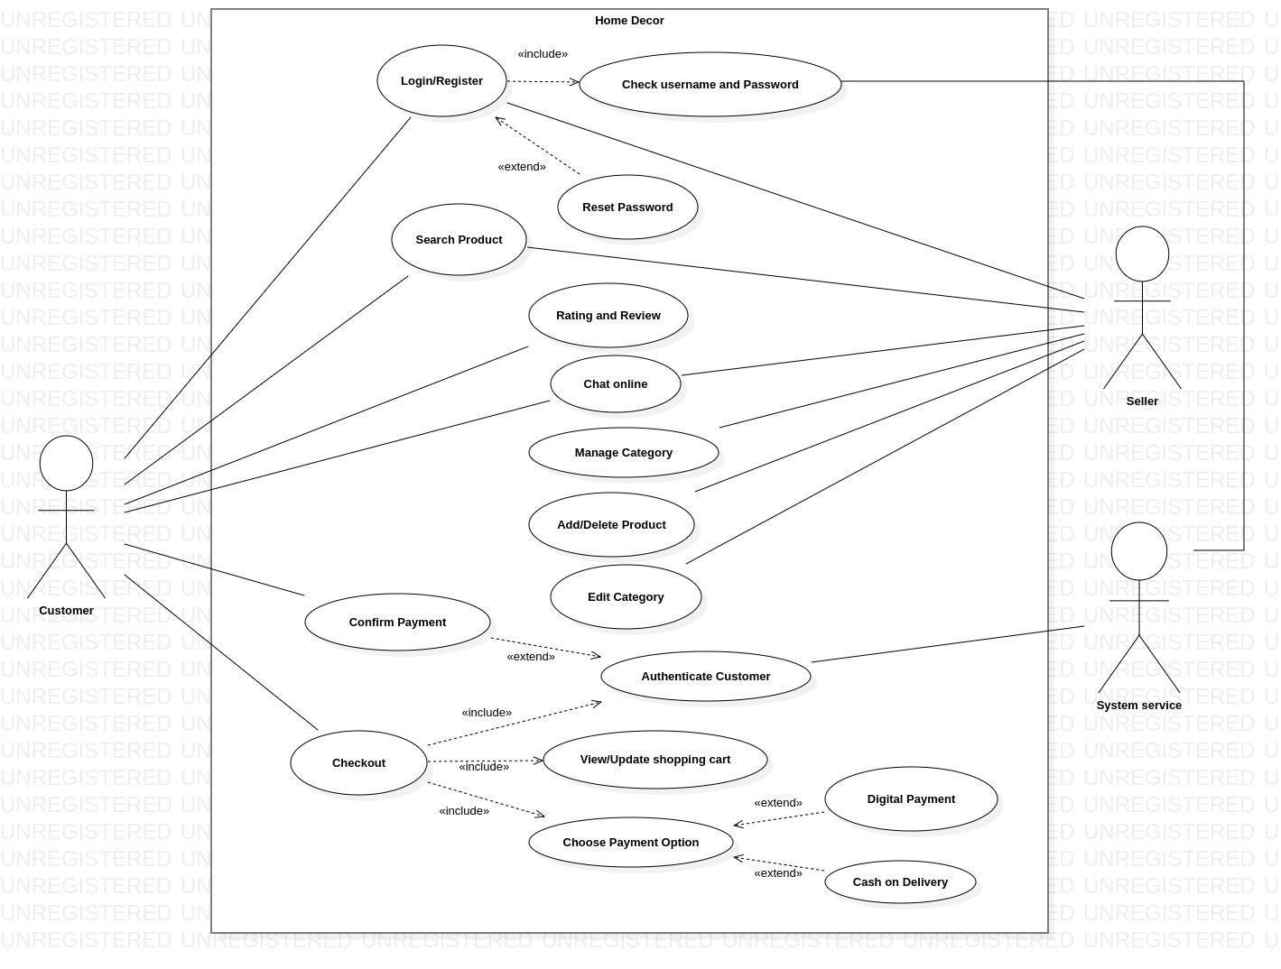

**Fig (1) : Use case diagram**

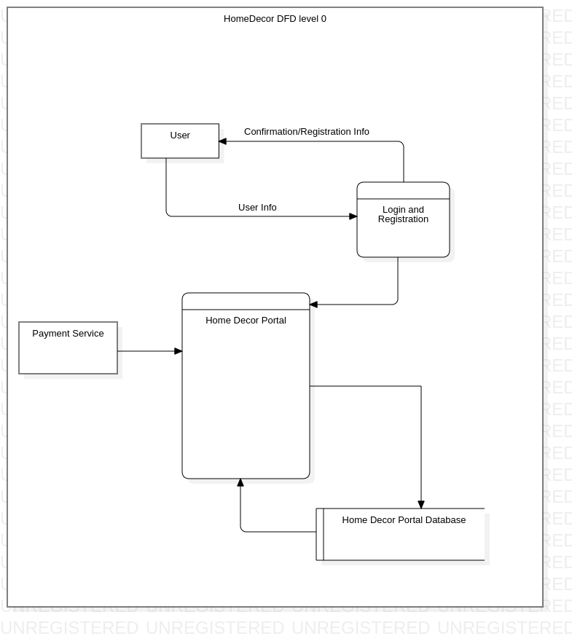

**Fig (2) : DFD level 0**

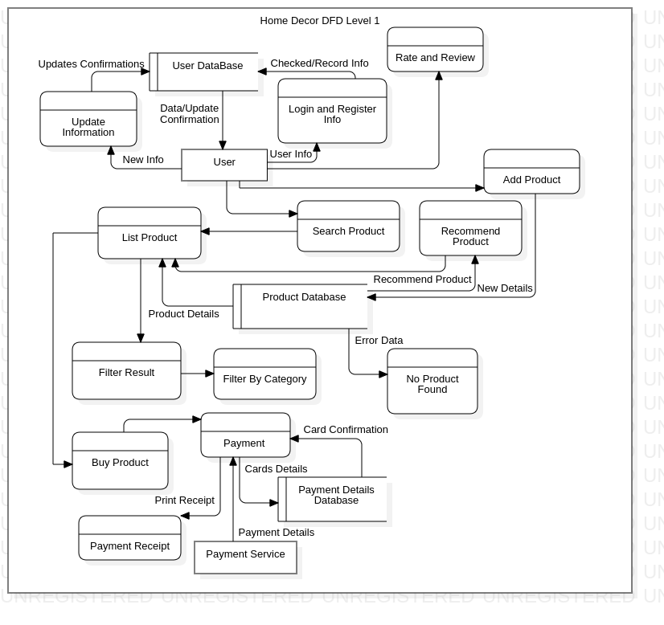

**Fig (3) : DFD level 1**

**Fig (4) : ER Diagram**

**Fig (5) : Class diagram**

**Fig (6) : Sequence diagram**

**Fig (7) : Activity diagram**

# METHODOLOGY

## SOFTWARE DEVELOPMENT APPROACH

We are using the **Incremental Software Model** in the SDLC of this project.We have been developing the project in some increments. In each successive increment, we added few functionalities. After completion of each increments, testing has been performed to ensure quality of the system. The remaining features will be added in future increments.

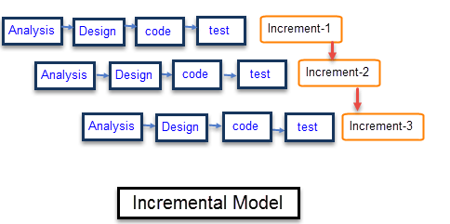

**Fig (8) : Representation of incremental model**

## PROJECT TOOLS

The entire project is divided into two phases of development: Frontend and Backend Development.

**Frontend Development**

The software tools used for frontend development are HTML, CSS and JavaScript.

* **HTML**HTML is the main markup language for creating webpages and other information that can be displayed in a web browser. HTML is written in the form of HTML elements consisting of tags enclosed in angle brackets (like ), within the web page content. The purpose of a web browser is to read HTML documents and compose them into visible or audible web pages. HTML elements form the building blocks of all websites and allows images and objects to be embedded and can be used to create interactive forms. It provides a means to create structured documents by denoting structural semantics. It can embed scripts written in languages such as JavaScript which affect the behavior of HTML web pages.
* **CSS**CSS is a stylesheet language used for describing the look and formatting of a document written in a markup language. CSS can allow the same markup page to be presented in different styles for different rendering methods. It can also be used to allow the web page to display differently depending on the screen size or device on which it is being viewed. CSS specifies a priority scheme to determine which style rules apply if more than one rule matches against a particular element.
* **JavaScript**JavaScript is a dynamic computer programming language. It is most commonly used as part of web browsers, whose implementations allow client-side scripts to interact with the user, control the browser, communicate asynchronously, and alter the document content that is displayed. It is also being used in server-side programming. The application of JavaScript to use outside of web pages. We are using a JavaScript framework, React JS for frontend development.

**Backend Development**

* **MySQL**MySQL is the widely used open-source relational database management system. Platform flexibility is a stalwart feature of MySQL with all flavors of Linux, UNIX, and Windows being supported. And, of course, the open source nature of MySQL allows complete customization for those wanting to add unique requirements to the database server.

With high-speed load utilities, distinctive memory caches, full text indexes, and other performance-enhancing mechanisms, MySQL offers all the right ammunition for today's critical business systems.

* **Java**

## RECOMMENDATION ALGORITHM

**Hybrid Based Filtering:**

Hybrid based filtering combines both content based and collaborative filtering.

**Content based filtering:**

It is based on profile of the user’s preference and the item’s description. CBF algorithm recommend items or similar to those items that were liked in past. It examines previously rated items and recommends best matching item.

**Collaborative filtering:**

It recommends items based on the similarity measures between users and items. The system recommends those items that are preferred by similar category of users It provides effective recommendations because it is based on user’s similarity rather than item’s similarity

Hybrid recommender system is the one that combines multiple recommendation techniques together to produce the output. The reason is the lack of information about the domain dependencies in collaborative filtering, and about the people’s preferences in content-based system. The knowledge increase makes it especially promising to explore new ways to extend underlying collaborative filtering algorithms with content data and content-based algorithms with the user behavior data.

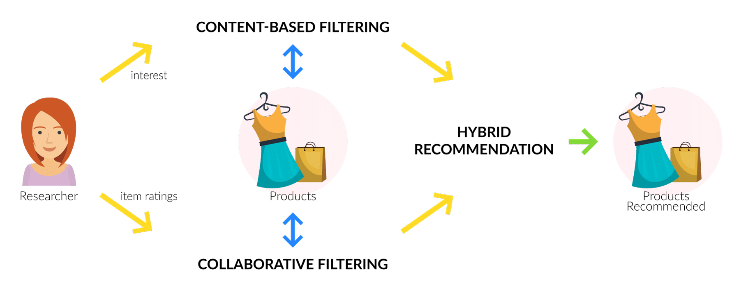

**Fig (5): Hybrid Recommendation System**

## Algorithm

**Step 1:**

Use content-based predictor to calculate the pseudo user-rating vector ‘v’ for every user ‘u’ in the Database.

**Step 2:**

Weight all users with respect to similarity with the active user. Similarity between users is measured as the Pearson correlation between their ratings vectors.

**Step 3:**

Select n users that have the highest similarity with the active user. These users form the neighborhood.

**Step 4:**

Compute a prediction from a weighted combination of the selected neighbors’ ratings.

In **Step 2,** the similarity between two users is computed using the Pearson correlation coefficient, defined below:

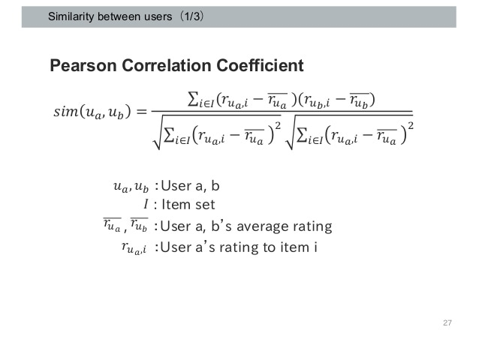

In **Step 4**, predictions are computed as the weighted averages of deviations from the neighbor's mean:

# TASKS ACCOMPLISHED

## Front-End:

We have completed the following tasks till date:

* Built basic structure of the website using HTML
* Added styling for the pages using CSS
* Created login & register page
* Created reactive elements such as image grids using React

## Back-End:

In terms of back-end development, we have accomplished the following:

* Connected java application with simple database to store and represent information
* Created a verification procedure that sends confirmation email on registering
* Added a simple authentication mechanism
* Included encryption mechanism to store sensitive information
* Created PostgreSQL database

# TASKS REMAINING

## Front-End:

The following tasks are still needed to be completed:

* Adding an overlay for notifications
* Adding an interface for chatting
* Creating an interface for cart system
* Making the website responsive

## Back-End:

We have the following tasks remaining in back-end:

* Adding an interface to retrieve product information from database
* Implementing the recommendation algorithm to recommend products to users
* Connecting the application with the complete PostgreSQL database

# REFERENCES/BIBLIOGRAPHY

[1] "Online shopping: The pensioner who pioneered a home shopping revolution". BBC News. 16 September 2013. Archived from the original on 17 July 2018. Retrieved 21 June 2018.

[2] "Dealing with other businesses online". Australian Competition & Consumer Commission. Government of Australia. Archived from the original on 19 January 2013. Retrieved 4 May 2021.

[3] Khurana, Ajeet (25 November 2019). "Did You Know That There Are 4 Types of Ecommerce?". The Balance Small Business. Dotdash. Archived from the original on 22 January 2021. Retrieved 4 May 2021.

[4] Millward, Steven (18 August 2016). "Asia's ecommerce spending to hit record $1 trillion this year – but most of that is China". Tech in Asia. Archived from the original on 19 August 2016. Retrieved 4 May 2021.

[5] "Electronic money and electronic commerce". BBC News. Archived from the original on 4 May 2021. Retrieved 4 May 2021.